**Project 2**

Fiona Liu(A16880107), Kexin Cheng(A15910812),

Tengyue Wang(A16338562), Rajvir Logani(A16041655)

DSGN 1 Winter 2022

9 AM Studio

**Interviews and Observations**:

**Brainstorming**:

During the brainstorming period, we used the **mind map** (Figure #1) to help us find an object to analyze. In the beginning, we listed lots of things in our daily life to find some inspirational thoughts. After finishing the mind map, our groupmate mentioned a common yet interesting object in his bedroom - the candle. We looked specifically at how when a candle has been burned for a while, it becomes challenging to use a lighter to burn the candle (see Figure #2). This phenomenon cultivated us to think critically about why the candle is so hard to ignite. We concluded that the reason is not particularly because of the candle, but because of the lighter that most people have on hand: the disposable spark wheel lighter.

Figure #1: The mind map for project 2 (significantly helped us to find an 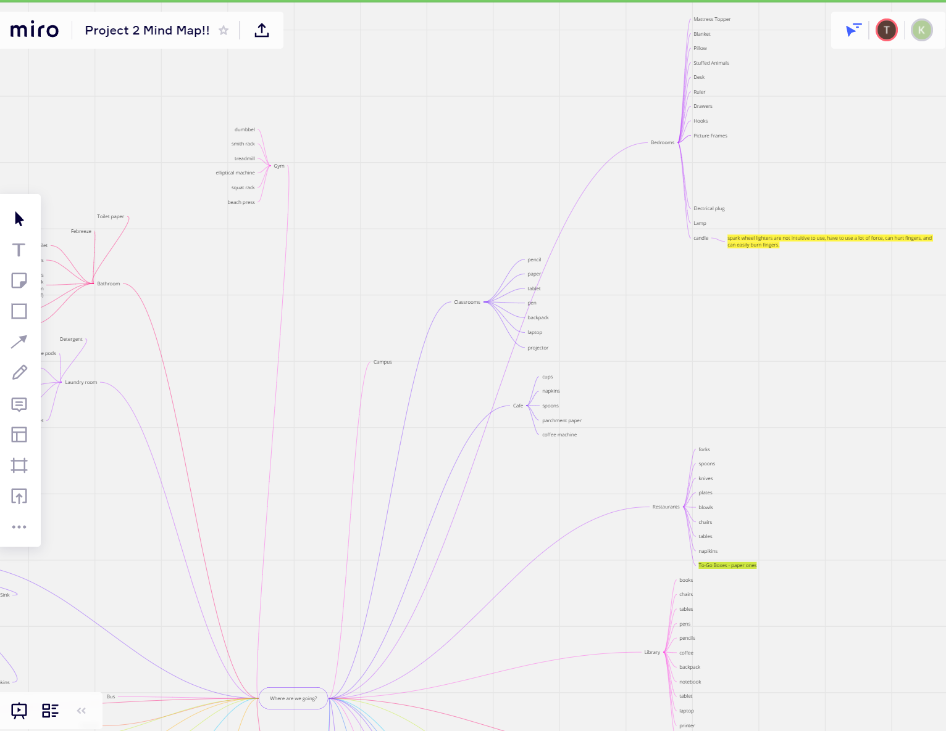

object for Project 2) <https://miro.com/app/board/uXjVOT6P-Xk=/>

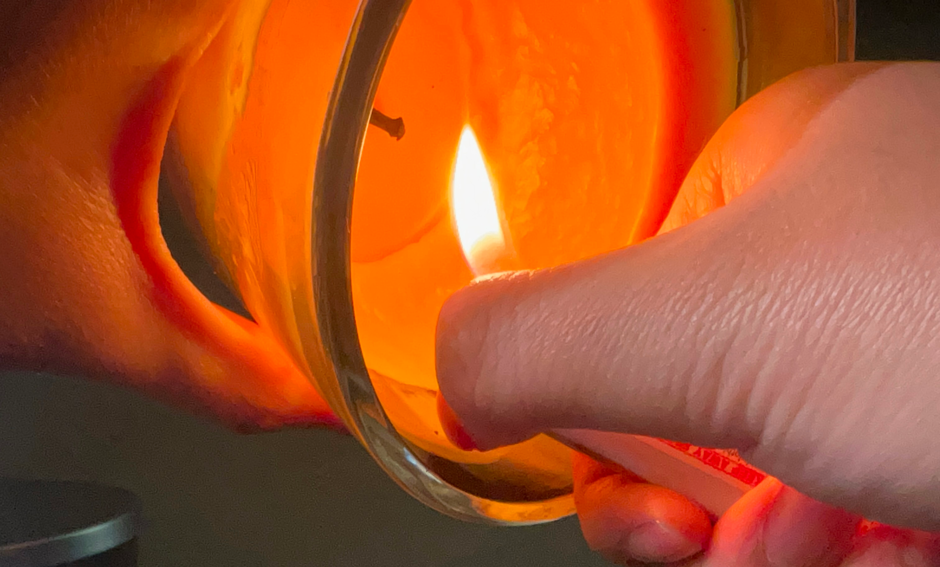

Figure #2: Difficulty reaching the candle

**Methodology**

We conducted interviews in two ways: conversational interviews and surveys. Both employed the same questions.

For the conversational method, we conducted 1 on 1 interviews either from video chat or face to face at home to have a better record of participants’ answers.

For those who were too far or unavailable to meet, we disseminated a Google Forms survey. We first interviewed our friends and families who were from different backgrounds (different countries, different jobs, different gender, etc.) with different age ranges, but who we knew had used lighters for a long period of time. We then expanded by putting this survey online in order to gather as many as responses from people with varying experiences.

1. “Say you’re handed this lighter - describe how you would go about using it.”

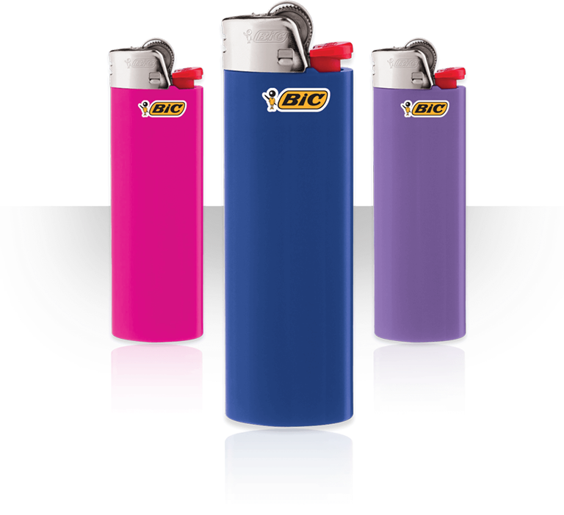

Figure #3: The specific type of lighter that our interview questions are based on

1. We ask this question in order to get to know the general ease of using the lighter. Different people may have different ways to handle the lighter, which may lead to different ways of using, or in other words, different ways of opening it. This question also helped us to see if the lighter included any clues that would **signify** to the user how to operate it. The question also helps us figure out the question: Do all people handle the lighters in the same way? If not, how is it different?
2. “Describe your experiences using disposable spark wheel lighters in the past. How do you feel about them?”
3. We ask this question in order to get to know if participants view disposable spark wheel lighters positively, negatively, mixed, or neutrally. This question is helpful since it indicates the experiences of those lighter users. Does the lighter’s **conceptual model** (designer’s intent) fit into the user's **mental model** (user’s understanding)? If yes, what makes it fit? If not, what makes it fail? This question also reveals what aspects of the lighters users care about more and their ideal aspects of the lighters.
4. “How do you know how to use a spark wheel lighter?”
5. We ask this question in order to get to know if the design of the lighter is intuitive to people, or they have to be taught to use it. This question is helpful since it indicates whether or not the lighters have **physical constraints** that ease interpretations or limit possible actions to users. This question also helped us to see if the lighter included any clues (any buttons, etc.) that would **signify** to the user how to use it. Through this question, we can also be aware of whether the users get to know how to use the lighters through **knowledge in the head** or **knowledge in the world.** If users do not know how to use it by themselves we can also determine the **gulf of evaluation and execution** that prevent them from knowing that.
6. In what situations would you use a lighter? What objects do you usually light?
7. We ask this question in order to get to know the general use and compare it to alternatives that can do the same. It can reveal **cultural constancy** in the usage of the lighters if we get quite trended responses (i.e. smoking).
8. How do you hold your lighter when lighting an object?
   1. We ask this question in order to get to know whether people use the product easily and identify the user **mental model** when using the lighter. Lighters have the **affordance** to be held by people, so this question helps us to find the **gulf of evaluation**, leading us to find the reason for the position of holding a lighter. Meanwhile, because of the basics of using a lighter with **knowledge in the head**, the question also allows us to determine most people’s lighter use habits.
9. How often do you use these lighters? When was the last time?
   1. This question helps us determine the user’s frequency of usage of the lighter. Due to the **physical constraints** of the lighter and personal requirements, we can know whether the user will choose to use the spark-wheel lighter based on its property (with unique affordance) or not. Meanwhile, asking this question helps us to separate data into three sections. First, people who use the lighter often, as it is essential in their daily lives. Second, people who use it occasionally. Or simply people who don’t need a lighter in their life. It will help us to make the data accurate and specific.
10. How much do they generally cost you?
    1. We asked this question in order to understand a **tradeoff** of if people put up with poorer qualities in the lighters because of an attractive cost.
11. How long does it generally take you to go through a spark wheel lighter? Have you ever refilled one?
12. We asked these questions in order to get to know usage (longevity) and compare it to the cost as a potential **trade-off**, since the lower cost lighter may not have the same longevity compared to higher cost lighters. This question gathers users’ ideas of balance between cost and other features (longevity, safety, etc.) of the lighters.
13. What are features (good/bad) about this type of lighter that stand out to you?
14. We asked this question in order to get to know the biases people have about the design (whether they think it’s good/bad). This question helps us to see which features satisfy the user’s **mental model** andwhich features do not. Also, it gives us an understanding of the **mapping** of the lighter’s design since we are asking for design features. When users are answering this question, they also reveal their understanding of the lighters. If they report bad features, it also reveals the faults in the **gulf of evaluation** and the **gulf of execution** when users use the lighter.
15. What kind of lighter do you typically use - why? Is this your preferred lighter to use? If not, describe what is.

a. We ask this question in order to get to know if people are satisfied or comfortable with the design features and functionalities of the lighter and identify what design features/functionalities of the lighter people are commonly looking for. This question also helps us to determine the lighter design’s **gulf of evaluation** and **gulf of execution** when users are picking what kind of lighter they prefer to use. Preferring to use an alternative one helps us find what type of lighter is more popular in the user's daily life and satisfy their **mental model.**

**Proof of Data**

We collected our data through surveys and in-person interviews, so we have one spreadsheet generated by the Google Form and one document of the data collected during the in-person interviews.

Figures #4 and 5: Survey sheet from the Google Form <https://docs.google.com/spreadsheets/d/1eYRYpwkp6N8arFMqc2HDVTqtpAgQTzRF6v4MTDNILFE/edit?usp=sharing>

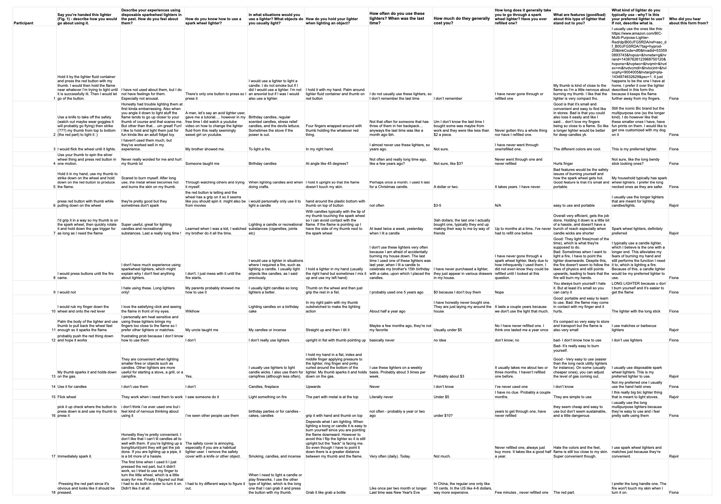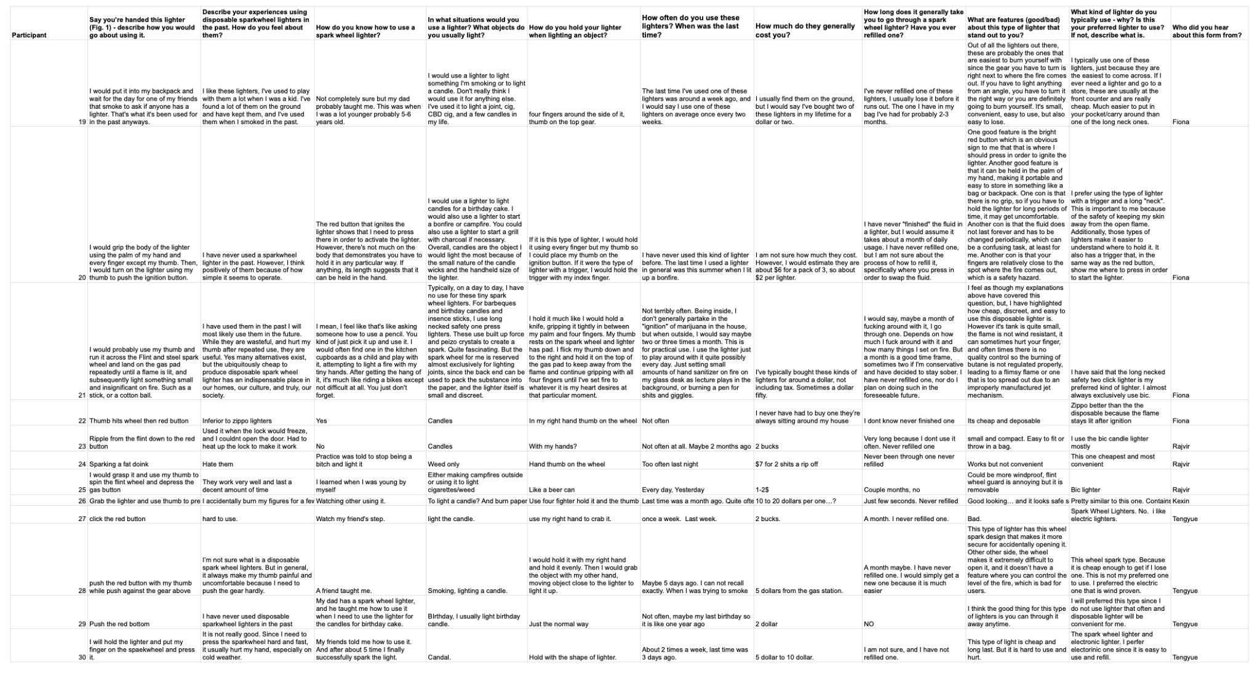

Figures #6, 7, and 8: Interview data

<https://docs.google.com/document/d/1lJAA2cKUURNKmjwTkCAyf1vVI-FuHZphwKg8sU0Fnko/edit?usp=sharing>

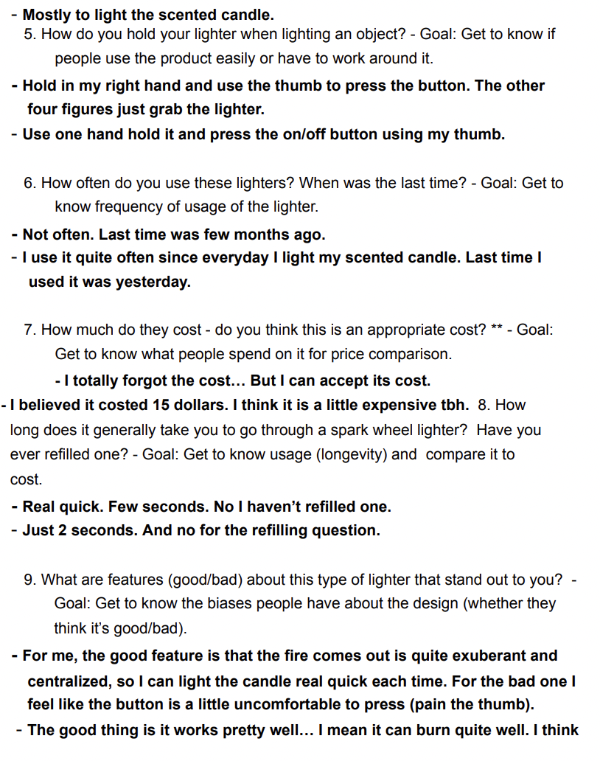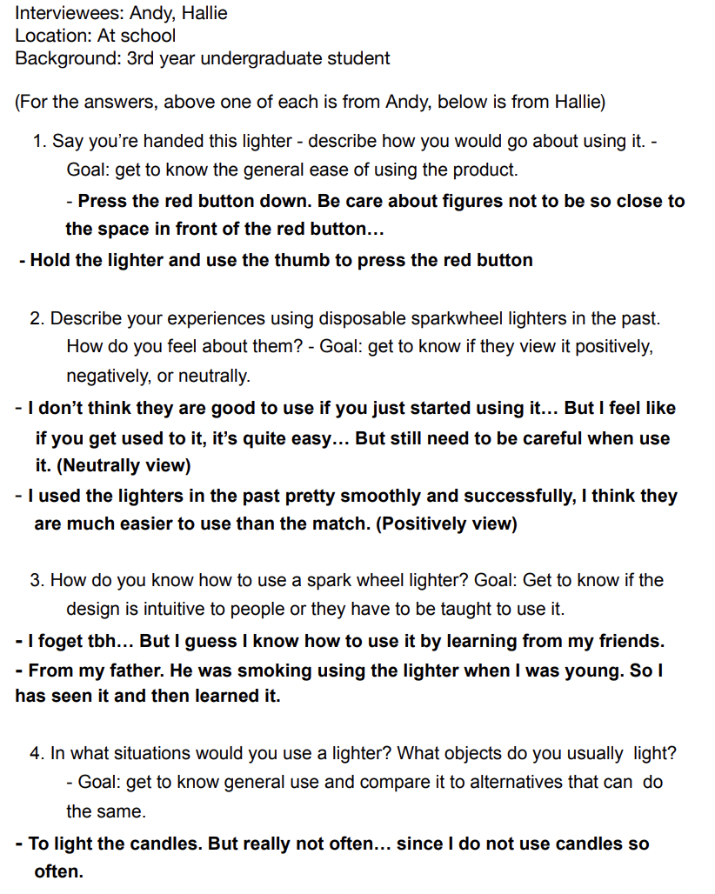

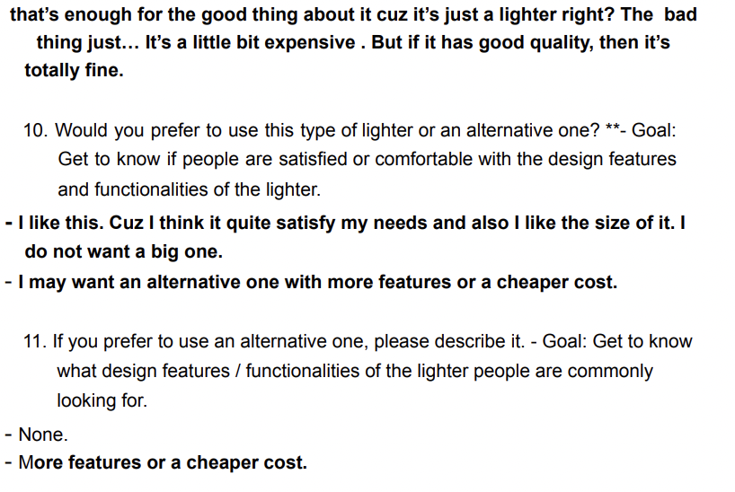

**Contributions**

Each person’s interview contributions can also be found in the sheets under the question “Who did you hear about this form from?”

Fiona: All interviews were done through Google Forms, 16 out of 32 total interviews (Participants 1-5, 8-10, 12, 14, 16, 18-22).

Rajvir: All interviews were done through Google Forms, 9 out of 32 total interviews (Participants 6-7, 11, 13, 15, 17, 23-25)

Fiona and Rajvir took care of the “Trends and Patterns”, “Tradeoffs”, and “Design Space Sections.” Fiona wrote and graphed the portions on General Experience, Danger, and Frequency and Usage, and also the Safety vs. Ease of Use and Quality vs. Cost comparisons. Rajvir took care of Convenience and Retention and Discoverability, as well as Reachability vs. Portability.

Tengyue: All interviews were done through Google Forms, 4 out of 32 total interviews (Participants 27-30)

Kexin: One interview done through Google Forms, two interviews done conversationally, 3 out of 32 interviews

(Participant 26 and two conversational interviews)

Tengyue and Kexin took care of analyses in the “Interviews and Observations” section.

All members participated in proofreading and editing interchangeably.

**Interview Techniques**

We conducted our in-person interviews and designed interview questions using the **master-apprentice model** during the process. Specifically, we wanted to make interviewees feel they were the “**masters**” of the interview so that they could take control of the interview process and tell us their own experiences as much as possible, rather than we, as interviewers, throwing a question and they answer a question one by one, which would restrict their thinking and make interviewees feel oppressed. Using the **master-apprentice model**, we told interviewees the premise of our interview and gave them enough time and space to express their opinions for lighters.For theinterview questions (which are also the survey questions), we wrote **open-ended questions** in order to leave space for interviewees to think of their experiences and organize their responses by themselves instead of restricting them to specific questions. We tried our best to **avoid leading questions** to avoid biasing the interviewees on responses. Some interviewees told us a story of their experiences of using lighters, some were more compelled to tell us about the features of the lighters they did not like, and some showed us actions of how they held or opened the lighters. The interactions between us and the interviewees were pretty comfortable under the use of a **master-apprentice model**.

**Trends and Patterns:**

**General experience:**

Before we dove into the details of the trends and patterns, we wanted to demonstrate some general experiences we observed in the interview responses. Our survey was composed of all open-ended questions, so this nominal scale was categorized at our discretion. We went through the second question on the survey, “Describe your experiences using disposable spark wheel lighters in the past. How do you feel about them?” to gauge the initial attitudes people held on spark wheel lighters, and designated them to a group based on the content of their responses.

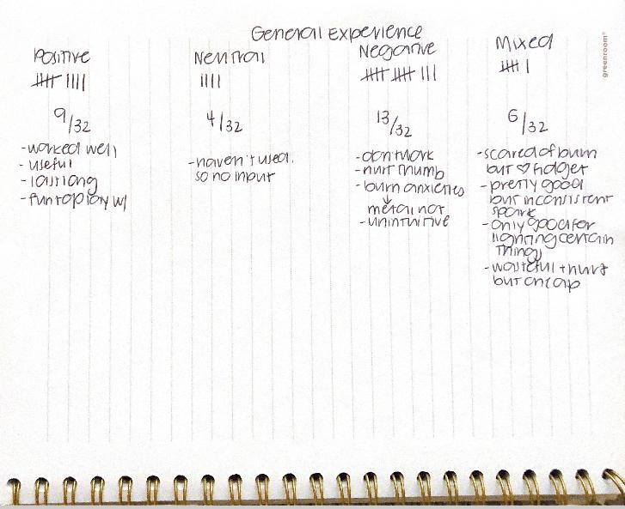

Figure #5: Initial tally

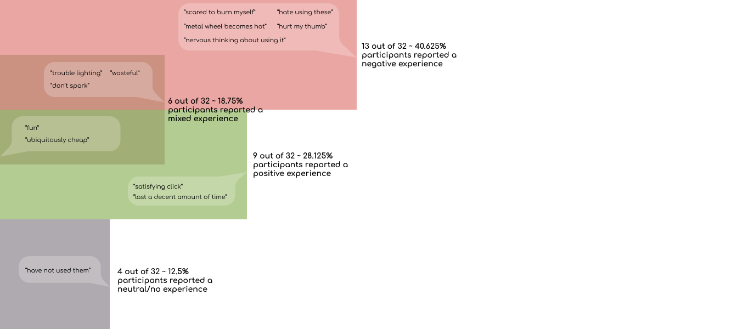

Figure #6: Final construction

**Dangers:**

Pain/fear when igniting:

When asked about their experiences using lighters, of the 19 responses that were either bad or mixed, 10 specifically reported experiences related to “hurt,” “burn myself,” “scary,” “nervous,” etc.

Furthermore, when asked about features of the lighter that stood out to them, of the 23 responses that offered bad features, 14 attributed it to “hurt,” “pain,” “fingers being so close to a flame,” etc.

**Problems with this:**

From here, there are two major concerns that can be identified.

1. The actual spark wheel gear used to ignite the fire is uncomfortable and painful. A large part of this is owed to the fact that it is often exposed, making the combination of the physical ridges and the necessary frictional action of rolling the wheel (and the tendency of the metal wheel to heat up) to inflict pain on its user. Though this particular problem does not fail specifically at affordances, signifiers, feedbacks, conceptual models, gulfs, etc., a large portion of it hinges on the **emotion of the user**, which Don Norman repeatedly brings up in his book. These unpleasant physical inflictions will impact the user’s **three levels of processing** that impact human cognition and emotion. The most directly affected will likely be on a **visceral level**, which draws upon the body’s musculature to notice sensitization. The **behavioral level** (yanking the finger away) and **reflective level** (fear and pain and consequent avoidance) will then follow.
2. Though the position of the red ignition button right under the wheel is sensible (as after rolling it the finger lands right on the button), the proximity of the spark wheel gear and ignition button to the fire is **poor** **mapping**. A representative method of lighting something is given by this one response: “Sometimes when I want to light a fire, I have to point the lighter downwards. Despite this, the fire doesn't seem to follow the laws of physics and still points upwards, leading to fears that the fire will burn my hands.” Because many objects that require lighting cannot be held upside down for fear of dripping (e.g. candles), the only other option is to angle the lighter itself. But because of this design, the finger is inevitably in the path of the flame, eliciting this pained response from so many users.

Child safety:

Interestingly enough, of the 9 responses that reported positive experiences with the lighter, a third accredited this to the spark wheel gear reminding them of a “fidget toy” and loving the “satisfying click;” one even explicitly said he “used to play with them a lot when I was a kid.”

**Problems with this:**

The **physical constraint** and **interlock** - something that forces operations to follow a proper sequence in order to work - of this design was a two-factor authentication that required you to roll the spark wheel and hold the red button at a fast enough speed in order to ignite the fire. But once one learns how to use it, even if they’re young, they’re able to fiddle around it, meaning the lack of a more effective **lockout** - something that prevents an action - can pose major safety hazards for children.

**Frequency and preference:**

The frequency at which people use these specific lighters could be categorized (at our analysis discretion) into three regularities:

Often (Daily/Weekly basis): 10 out 32 interviewees reported using these lighters often, and 7 of these 10 listed good features to be “efficient,” “easy to use,” “convenient,” “works,” “cheap,” etc. Upon further inspection, 2 of the 4 people who voluntarily disclosed that they smoked were ‘often’ users of this type of lighter, the other 2 being ‘occasional’ users of this type of lighter. The value and ‘often’ frequency at which these people use these lighters can therefore likely be attributed to their necessity for portability and pricing in accommodating their activities.

Occasionally (Monthly basis): 7 out of 32 interviewees reported using these lighters occasionally. Of those who did offer insight on their use for these lighters, many cited “candles,” “Christmas,” “New Year’s Eve,” etc. This frequency, then, seems to hinge on seasonal necessities.

Rarely (Yearly basis): This was the largest population, with almost half - 15 out of 32 - interviews saying that they rarely or never use these lighters.

When asked for their preferred lighter, 11 of those 15 directly answered the “long-necked” ones. It seems that these participants rarely use this specific lighter because they have another style that better suits their more domestic needs. Also, lighter-using is mostly connected with smoking, candle use, etc. Those activities that require using lighters are pretty associated with personal habits.

**Problems with this:**

The portability and inexpensiveness of the spark wheel lighter paired with the **cultural** tendency to smoke increases the lighter’s **standardization**. The interviewees tend to justify and settle for the lower quality/reachability and pain of the lighter simply because it “does the job.” Understandably, this could be a **trade-off**, but it is important to note that though each lighter is used for its respective purposes (e.g. you likely wouldn’t carry around a long neck lighter just to light your cigarette), it may be difficult to have to switch between the two.

**Convenience and Retention:**

Something we noticed while looking at the results of our interviews was that a third of our interviewees highlighted how they thought that spark wheel lighters were convenient. Additionally, 7 interviewees praised these lighters specifically for being “small” and “portable,” so it’s easy to carry. Another trend we saw in our data was regarding the retention, referring to the lighters’ ease of keeping track of where it is or losing it, of spark wheel lighters that our interviewees had. We found that out of 32 of our participants, 9 (just under a third) have never gone through a single spark wheel lighter, another 9 out of our 32 participants generally take between 1 and 6 months to go through one, and 3 generally take a year or more to go through one. Additionally, not a single one of our participants had ever refilled a spark wheel lighter for reuse. Of the 4 participants who smoked/had smoked, only two of them said that they go through them regularly within a couple of months. One of the other smokers said they had never been through a spark wheel lighter and the last one interestingly said that they always lose them before finishing them. Coming across this point allowed us to recognize an interesting trend in the responses we got. While we only found that 3 out of our 32 participants tend to lose their spark wheel lighters, we found that one of those participants, along with another 3, has and uses spark wheel lighters despite having never bought them. These people would find them “laying around the house” or “on the floor.”

**Problem with this:**

This means that almost a third of our participants have either lost a spark wheel lighter or gotten one because someone else lost it. This is not necessarily a large trend but it was one that we were not expecting to see. This trend suggests that while the design is small and easy to carry around, it’s also quite easy to forget or leave places. This demonstrates that while these spark wheel lighters are common, the **cultural constancy** of these lighters as a disposable item in a way devalues them and makes them forgettable. If something is forgettable, it’s easy to lose track of.

**Discoverability:**

In *The Design of Everyday Things* by Don Norman, **discoverability** is defined as the ability to know “what actions are possible and the current state of the device” (Norman 72). The discoverability of a device is determined by its users. Based on the data we collected through interviews, we found that spark wheel lighters seem to have a relatively low level of **discoverability**. When we asked how the interviewees know how to use spark wheel lighters, 19 out of 32 interviewees responded that they had to learn from a source such as a parent/relative, friend, or media source. Additionally, 5 interviewees learned how to use a spark wheel lighter from trial and error, 2 interviewees described an incorrect way to use them (because they did not know how to use them as they mentioned in answers to previous questions), and 2 interviewees just admitted they didn’t know how to use a spark wheel lighter. This means that 30 out of the 32 interviewees didn’t initially know how to use a spark wheel lighter based on the design. All 30 either needed help so they could learn, had to “fidget” with the lighter until they realized how to use it, or just never learned in the first place.

**Problems with this:**

The evidence above tells us that these spark wheel lighters are not easily **discoverable**. There is very clearly a learning curve required for these lighters, as can be seen by the 24 out of 28 interviewees who knew how to use a spark wheel lighter but had to be taught or use trial and error. The design was not simple enough to immediately be understood by these people. Using the definition of discoverability mentioned above, the current state of the design isn’t incredibly difficult to decipher considering the only options are the lighter being on or off (as can be determined by the presence of a flame or not). Thus, it is possible that a lot of our interviewees have had trouble with the available actions. This is broken down into the **affordances** and **signifiers** of the lighter itself.

**Affordances**: The design of a spark wheel lighter has many **affordances**. It can be held, thrown, placed in small areas for storage or transportation, and much more. There are only 3 functional **affordances** though, the ability of the button to be pushed/held, the ability of the button to be released, and the ability of the spark wheel to be turned/spun.

**Signifiers**: Spark wheel lighters have different designs but the one we provided to interviewees for reference during their interviews is the one in Figure 7 below. The most prominent **signifier** on the device is the red button that sticks out on the right side, telling the user that it can afford pushing. The only other noticeable **signifier** on the device is the ridges on the spark wheel itself, telling the user that the piece provides grip and can be interacted with.



Figure#7: BIC Spark Wheel Lighters (Same as figure 3, provided again here for reader convenience)

The **signifier** the button provided was quite obvious to our interviewees. When asked how they would go about using the lighter in Figure 7 above, 20 out of the 32 people who were interviewed mentioned pressing a “red thing”, “button”, “lever”, and other terms in reference to the red button displayed on the right side of the lighter in Figure 7. Additionally, 3 out 4 of the people who did not know how to use spark wheel lighters demonstrated their understanding of the button and its **affordance** to be pushed by responding that they would “probably push the red thing down and hope it works” when asked how they’d use the lighter in Figure 7. Only 17 out of the 32 responses to this same question even mention the use of a “spark wheel”, “wheel”, or “flint”, or the action of “sparking” itself. That’s barely more than half of the interviewees as a whole. The **signifier** the wheel does not offer the same clarity to the interviewees as the **signifier** the button offers. Additionally, it is not made clear which piece is meant to be interacted with first. In order to ignite a flame with the lighter, it is required to first spin down the lighter, and then hold down the button. There is no way for a user to know this order of actions by just looking at the device, there is no signifier for that. Additionally, if these actions are not done quickly enough in relation to one another, the lighter will not light. Thus even if the user takes the correct actions in the correct order, it could still not work.

The complexity of the functions for requirement along with the fact that most interviewees had to either be taught or use trial and error to learn how to use a spark wheel lighter suggests that knowledge of the use of this product is more **knowledge in the head** than **knowledge in the world**. **Knowledge in the world** includes the perceivable cues that a design offers. As discussed above, while certain functional affordances are made clearer than others in the design, even if a user knows how to interact with a spark wheel lighter, it is still possible for them to get it wrong. Thus this design makes poor use of **knowledge in the world** by not having clear **signifiers** as to proper interaction to make the device work. The fact that interviewees had to learn to use these lighters is proof of **knowledge in the head**, which is knowledge derived from one’s memory and experiences. As one interviewee said “After getting the hang of it, it's much like riding a bike except not difficult at all. You just don't forget.” This product makes the most use of **knowledge in the head** and the passing of this knowledge to have users understand how to use it rather than making it clear to the users through the design how it should be used.

**Trade-offs**

Trade-offs, as defined in *The Design of Everyday Things*, are the advantages gained from one quality at the expense of losing another.

**Safety vs. Ease of Use**

Safety in this context would be defined as how controllable the ability to light a fire is (e.g. if a child gets a hold of it), while ease of use is the readiness of the flame to ignite. Many reported instances of pain when trying to roll the spark wheel and the spark wheel ultimately not even working, but this could be in part because of the two-factor authentication **lockout** (spark wheel and ignition button) that could have been implemented specifically to prevent too easy of use. The greater the safety measures to prevent misuse by first-time users, the lower the ease of use.

**Quality vs. Cost**

Quality in this context could be defined to include the materials and the consequent ability of the lighter to regularly and effectively work over as long a period of time as possible. Cost here is defined as the affordability of the device, so how high or low the cost is.

The spark wheel lighter was praised for its cheap and travel-friendly compactness, with prices ranging between $1 to 3 USD in general (as seen in the responses of the interviewees), making it a standard **cultural constancy** that can be found everywhere. However, because of the compactness and low selling price, there is a sacrifice of certain manufacturing materials, which is likely what evoked so many responses of pain (from the exposed gear), or little success igniting the flame. The higher the cost, the lower the quality.

**Reachability vs. Portability**

As mentioned above, a significant portion of our interviewees claimed that they liked spark wheel lighters because they were “small” and “portable.” Many of our interviewees (including some of the ones who praised it for the lighter’s great portability), however, claimed that they have fears of burning themselves with these lighters. The reach of spark wheel lighters is pretty low, igniting the flame very close to the user’s finger. Reachability would be useful to a user in cases like that displayed in figure #2, where they need to light something like a used candle that might be difficult to access. The spark wheel lighter’s limited reachability, however, allows for the item to maintain a small size that’s convenient for people who might need a lighter more often to carry around. For example, someone who smokes more often (say multiple times in a day) might need something more portable that they can carry around rather than something with a longer reach. Thus, the designers for these spark wheel lighters traded off reachability for portability.

**Design Space**

For our design space, we chose to compare disposable spark wheel lighters to designs of:

2) [Long neck candle lighters](https://www.amazon.com/BIC-Multi-Purpose-Lighter-Colors/dp/B00I4CCJL4/ref=asc_df_B00I4CCJL4/?tag=hyprod-20&linkCode=df0&hvadid=532484193990&hvpos=&hvnetw=g&hvrand=10772287283477688042&hvpone=&hvptwo=&hvqmt=&hvdev=c&hvdvcmdl=&hvlocint=&hvlocphy=9031300&hvtargid=pla-1440838485092&th=1): The ones referred to most commonly by our interviewees

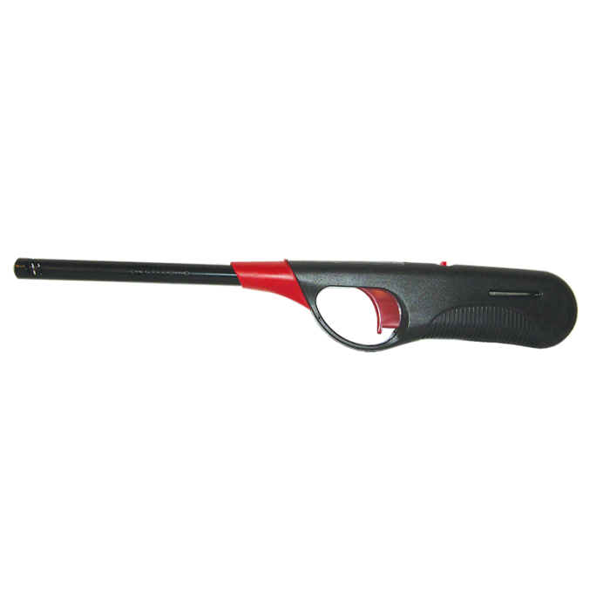

Figure 8: Long neck candle lighter

3) [EZ Reach lighters](https://www.amazon.com/BIC-Lighter-Assorted-Colors-Lighting/dp/B08J3Y5JR1/ref=sr_1_5?crid=FSIMSF7M7VE7&keywords=bic+lighters&qid=1643588555&sprefix=bic+%2Caps%2C168&sr=8-5): BIC’s own improvement on the disposable spark wheel lighter that is essentially a mini long neck candle lighter

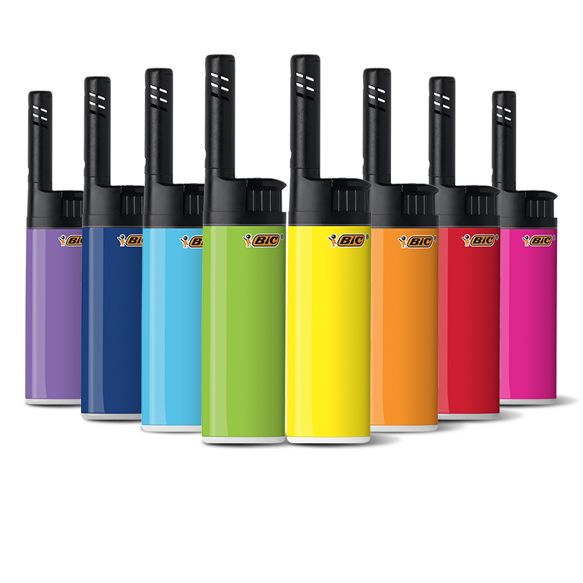

Figure 9: EZ Reach lighters

4) [Rechargeable electric candle lighter](https://www.bedbathandbeyond.com/store/product/modwix-ecolighter-slim-rechargeable-flameless-lighter-in-rose-gold/5682778?skuId=20750589&store=31&enginename=google&mcid=PS_googlepla_nonbrand_outdoorutility_local&product_id=20750589&adtype=pla&product_channel=local&adpos=&creative=232742511028&device=c&matchtype=&network=g&utm_campaignid=71700000037211784&utm_adgroupid=58700004137797650&targetid=92700034062220896&gclid=Cj0KCQiArt6PBhCoARIsAMF5wair_jNXJsePYmISPbuvVZnkvya13iHNwSegMZeFIplAbDzunRtvfEkaAqFrEALw_wcB&gclsrc=aw.ds): A pen-like electric lighter

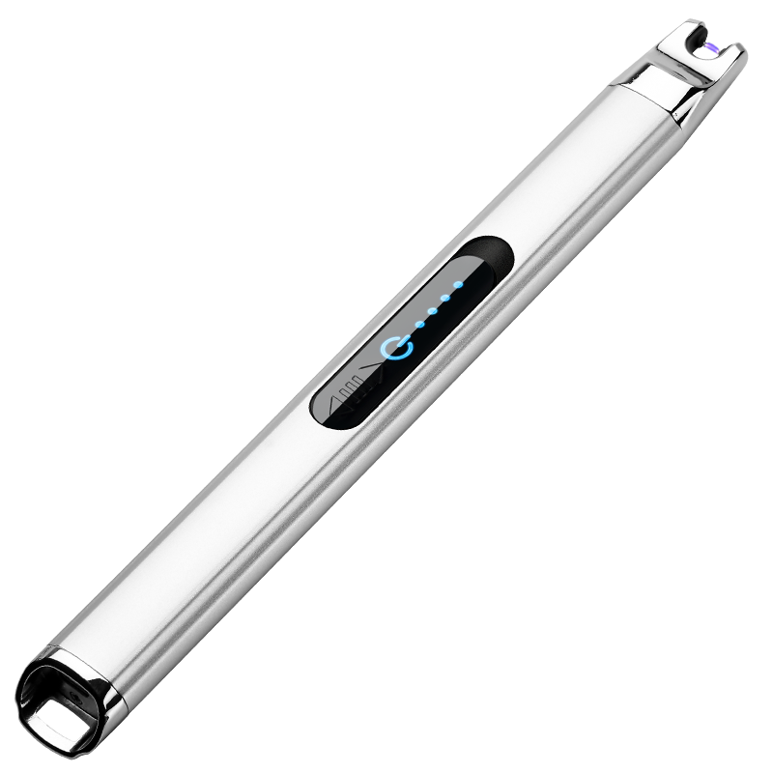

Figure 10: Rechargeable electric candle lighter

5) [Rechargeable Telescopic Plasma Lighter](https://www.amazon.com/MENG-ZHI-AO-Rechargeable-Telescopic/dp/B07VCFZ3G4): Like the electric candle lighter, but has an adjustable neck length

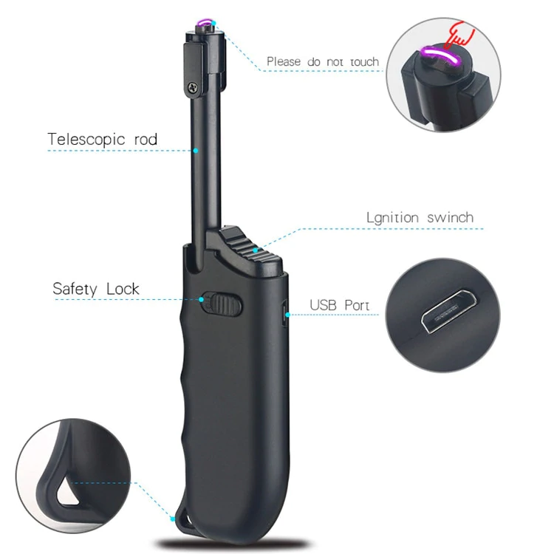

Figure 11: Rechargeable Telescopic Plasma Lighter

1. This was our ideal design. It combated interviewees’ major concerns over pain (the trigger is considerably less puncturing than the spark wheel gear) and reachability for objects like candles while maintaining portability and safety by offering customization in neck length.

Safety vs. Ease of Use



|  | **Item number** | **Type of lighter** | **Safety**  **Unsafe = 1**  **Very Safe = 10** | **Ease of Use**  **Not Easy to use = 1**  **Very Easy to Use = 10** |
| --- | --- | --- | --- | --- |
| **Disposable Spark Wheel Lighter** | #1 | Gas lighter | 7 | 4 |
| **Long neck candle lighter** | #2 | Gas lighter | 6 | 8 |
| **EZ Reach lighter** | #3 | Gas lighter | 5 | 8 |
| **Rechargeable electric candle lighter** | #4 | Electric lighter | 8 | 7 |
| **Rechargeable Telescopic Plasma Lighter** | #5 | Electric lighter | 8 | 8 |

The graph and table show the comparison between lighter’s safety level and ease of use level. We ranked each lighter based on participants’ major concerns. The design space figure shows the probable relationship between lighter’s ease of use and its safety; as seen in the graph, safety can come at the expense of ease of use.

Cost vs. Quality

|  | **Item number** | **Type of lighter** | **Quality**  **Low Quality = 1**  **High Quality = 10** | **Cost**  **Low Cost = 1**  **High Cost = 10** | **Price (specified)** |
| --- | --- | --- | --- | --- | --- |
| **Disposable Spark Wheel Lighter** | #1 | Gas lighter | 4 | 1 | About $1 |
| **Long neck candle lighter** | #2 | Gas lighter | 6 | 2.5 | About $3.20-4 |
| **EZ Reach lighter** | #3 | Gas lighter | 5 | 2 | About $3 |
| **Rechargeable electric candle lighter** | #4 | Electric lighter | 7 | 8 | About $12-14 |
| **Rechargeable Telescopic Plasma Lighter** | #5 | Electric lighter | 8 | 10 | About $15 |

The graph and table displayed above compare the quality of the different lighters stated above with their cost. The design space identifies the cost you would pay for the variable qualities of the lighters and displays a trend that the higher quality lighters are generally the more expensive ones as well.

Reachability vs. Portability



|  | **Item number** | **Type of lighter** | **Portability**  **Not Very Portable = 1**  **Easily Portable = 10** | **Reachability**  **Limited Reachability = 1**  **Further Reachability = 10** |
| --- | --- | --- | --- | --- |
| **Disposable Spark Wheel Lighter** | #1 | Gas lighter | 10 | 1 |
| **Long neck candle lighter** | #2 | Gas lighter | 4 | 10 |
| **EZ Reach lighter** | #3 | Gas lighter | 8 | 5 |
| **Rechargeable electric candle lighter** | #4 | Electric lighter | 5 | 7 |
| **Rechargeable Telescopic Plasma Lighter** | #5 | Electric lighter | 9 | 8 |

The graph and table displayed above compare the reachability of each of the lighters stated above with their portability. The design space identifies the trend of how the more portable a lighter design is, the less reachable it tends to be. The exception to this is our ideal design which implements a telescopic part, allowing the lighter to be both portable and as reachable as the user desires.

**Extra Credit**

[Extra Credit Link](https://drive.google.com/file/d/1nU4qxSTAHY_G_9To0Tj_vZKbUPFAhzK5/view?usp=sharing)